MUSICAL DINNER
& WINE PAIRING
with Claire-Marie, Soprano & Flautist presented by Colin Harkness, International Wine Judge
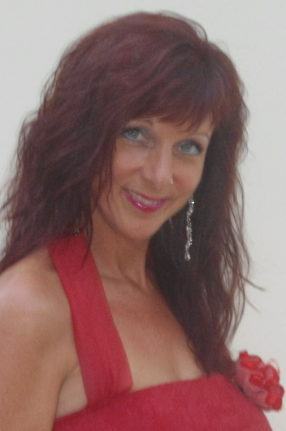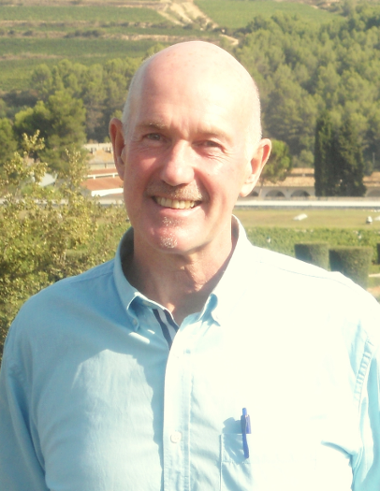
Casa Cantó, Benissa
Friday 12th May 2017
8.00 p.m.
Excellent, Gourmet 5-Course Dinner paired with 6 specially selected wines, sourced from different areas of Spain, accompanied by a magical performance of love songs, pop-opera and flute favourites! Only 35€!
To reserve, call Colin on 629388159 or email colin@colinharknessonwine.com
www.colinharknessonwine.com  Colin Harkness  @colinonwine www.clairemarie.es Claire-Marie Soprano @clairemsoprano

